**Job Description - Head of Operations**

# The role

**Job Title:** Head of Operations

**Location:** Various across Ubico

**Reporting to:** Operations Director

**Management responsibility:** Operations and transport managers

**Salary:** Competitive

**Contract terms and hours:** Permanent, Full Time 37 hour per week

# Job purpose

To provide strategic direction, operational delivery and continuous improvement of waste collections, recycling, street cleaning and grounds maintenance services across Ubico.

You will ensure high-quality cost-effective services that enhance the local environment, ensuring clean, safe and welcoming streets, neighbourhoods, parks and open spaces.

You will support our partners with climate and sustainability goals and deliver positive outcomes for residents and the communities. Driving efficiency, harnessing new technologies whilst embedding any changes ensuring the values are maintained. Collaborating with our partners to identify opportunities for growth across Ubico.

**Our Values**

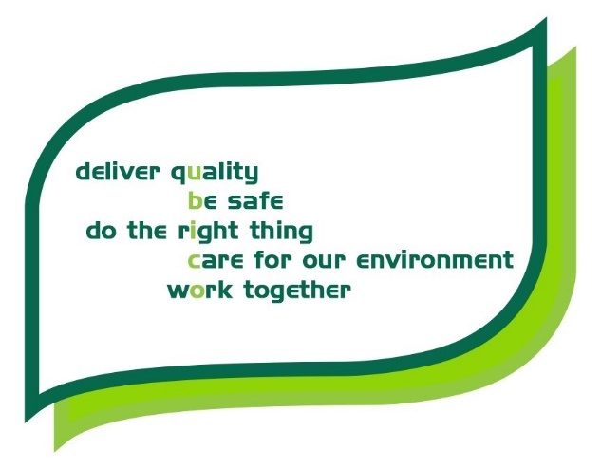

# Key responsibilities

The postholder will:

* Work with the executive leadership team to support the delivery of an effective service across Ubico.
* Lead the strategic direction of all collections, grounds maintenance and streets cleansing services in line with Ubico’s and its partners priorities, UK legislation and environmental objectives.
* Contribute to the wider environmental strategy including cardon reduction and waste reduction.
* Develop and deliver service improvement plans that focus on efficiency, customer satisfaction and long-term sustainability.
* Oversee the delivery of all operational streams through a team of operations managers ensuring effective delivery of services across Ubico that meet excellent quality standards and value for money.
* Lead and coach a team of operation managers to ensure that services are responsive, reliable and delivered to agreed standards across all operational streams.
* Develop and monitor key performance indicators (KPI’s), ensuring services meet internal targets and statutory requirements.
* Manage budgets and ensure services are delivered within the financial parameters, identifying savings and efficiencies where possible.
* To undertake risk management within the company’s policy and make recommendations to ensure ongoing improvements
* Support strategic initiatives and be an active member of the senior leadership team, actively supporting the achievement of our business aims and strategies that deliver value back to shareholders and make a positive contribution to the communities that Ubico serves.
* Lead the Operations Division to ensure that Ubico’s services are compliant with all relevant legislation and procedures and drive continuous improvement in Ubico’s operational systems and processes to be an example of best practice
* Provide advice, recommendations, policies and procedures relating to the provision of the service.
* Maintain constructive and productive working relationships with commissioners, shareholders, customers, trade unions, partners, other agencies, voluntary groups and community groups.
* To prepare and present reports associated with operations for the Board of Directors, service commissioners, scrutiny meetings, executive and council meetings.
* Prepare resource plans and develop budgets for operational service delivery and agree with the Director of Operations.
* Lead in emergency management and business continuity management.
* Ensure compliance with our operator licence undertakings and Ubico fleet compliance.
* Promote and practice health and safety policies and safe systems of working collaborating with SHEQ to promote continuous improvements.
* Exercise proper and absolute integrity in respect of all confidential matters and the confidentiality of personal and sensitive information in line with current data protection legislation.
* Work in compliance with the codes of conduct, regulations (including financial) and policies of the organisation.
* Attend board meetings when requested.

# People responsibilities

The postholder will:

* Provide strong leadership to the managers and teams, supporting professional development, wellbeing and performance management.
* Lead a positive organisational culture that is focussed on providing high quality and efficient services and adheres to the highest health and safety and compliance standards.
* Embed a culture of continuous improvement, staff engagement and high standards of customer service.
* Maintain an inclusive culture that seeks to provide and promote opportunity to all.
* Lead by example, act as a positive role model at all times and work to embed the Ubico values in all staff.
* To ensure that an effective performance management and continuous improvement regime exists within all operations to meet the challenges of service efficiency.
* Identity and nurture internal talent through effective succession planning, ensuring future leadership capability and service continuity.

# Other responsibilities

* The role requires occasional weekend or evening work, for example board meetings, council meetings and special events.
* The role requires the ability to drive, including a full driving licence and use of a vehicle with appropriate insurance in place.
* The company’s head office is in Cheltenham, but the role requires regular travel across the company’s operating area, with mileage paid for additional travel.

**Qualifications**

* Certificate of Professional Competence in Transport Management (Road Haulage).
* Certificate of Technical Competence (COTC) Level 4 - Managing Transfer Operations.
* IOSH Managing Safely certificate or recognised equivalent or prepared to work towards.

# Background and experience

**Skills and knowledge**

* Knowledge and experience of NEBOSH would be desirable.
* Experience of having operated as a member of a senior management team.
* Demonstratable experience managing complex, multi-site services and large operational teams.
* Experience of working in partnership with a wide range of stakeholders demonstrating effective partnership working, and collaboration; developing and maintaining positive and productive relationships with a range of internal and external stakeholders and strategic partners.
* Experience of formulating and implementing strategies, policy and procedures.
* Experience managing budgets and driving performance improvements in a service led environment.
* Strong understanding of environmental legislation, health and safety regulations and public sector service delivery.

**Personal qualities**

* Customer focussed, responsive, and co-operative with partners and stakeholders.
* High level of judgement, tact, discretion and initiative.
* Ability to record and deal with data accurately and effectively.
* Excellent verbal, written and presentational skills; with the ability to engage a range of audiences and positively represent the company.
* Good interpersonal skills; works together with employees, colleagues and customers to resolve problems and implement change initiatives.
* Excellent organisational skills, able to prioritise and meet tight deadlines.
* Lead by example and be a positive role model for Ubico values to ensure these are understood and embedded within teams, working practices and behaviours.
* Embraces innovation and continuous improvement.

# What we offer

* A competitive salary.
* A high degree of flexible working.
* Generous holiday allowance of 26 days plus bank holiday increasing to 30 days after five years.
* Opportunities to grow within the company and shape our strategy.
* Employee discounts across major retailers and attractions, days out, restaurants and holidays.
* Access to our employee assistance programme which offers a confidential service for employees and their families 24 hours a day / seven days a week.